**An in-depth understanding of WeRateDogs**

WeRateDogs, a popular Twitter account with nearly 7.6 million followers as of December 2018, rates people's dogs by asking them to send photos and then tweeting selected photos with humorous comments and ratings that exceed the maximum scale of one to ten. The existence of these seemingly nonsensical ratings is justified by the famous quote "They're good dogs Brent," which was part of a celebrated exchange between the account and a person who questioned their rating system. Despite this, the unique rating system contributes significantly to the popularity of WeRateDogs.



Look at the tweet above, "This is Patsy. She fell asleep in the rain and is now convinced she’s having an out-of-body experience". After reading numerous captivating tweets, I became curious about the popular dog breeds that people like to tweet about. I am interested in knowing the average ratings for these breeds and determining the most common dog stage mentioned in all the tweets. For my analysis part of the project, I will primarily focus on addressing these questions. To conduct this analysis, I have collected data from various sources with different formats, which were carefully evaluated and cleaned before proceeding with analysis and visualization.

1. **What are the popular dog breeds?**

Even though the Twitter account is called WeRateDogs, not all of the tweets are about dogs. While working with the data, I discovered many tweets that were not about dogs, such as chickens, jaguars, or bananas. Because they were not related to the topic I wanted to analyze, I deleted the data.

After cleaning the data, I can analyze more specifically about popular dog breeds. By examining the graph below, we can gain insights into the popularity of various dog breeds based on the number of tweets associated with each breed.

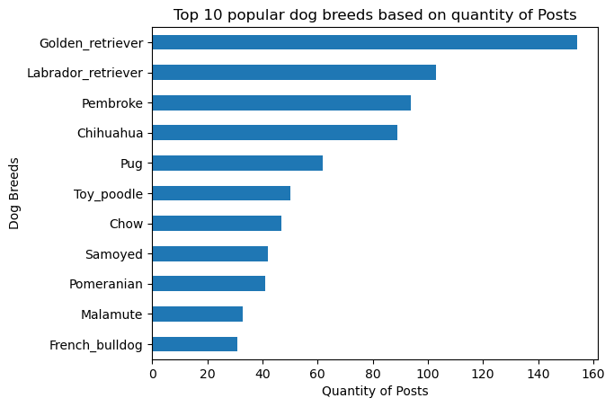

From the chart we can see that Golden Retriever is the dog with the most searches (about more than 160 tweets). Ranked in 2nd place is the Labrador Retriever with more than 100 tweets. The next three positions in the top 5 are Pembroke, Chihuahua and Pug. We'll then plot to see popular dog breeds based on number of retweets and favorites.

In addition to the number of tweets, it is crucial to consider the variables of retweets and likes. Therefore, the subsequent step involves creating a visual chart that depicts the popularity of various dog breeds based on the number of retweets and likes they receive.

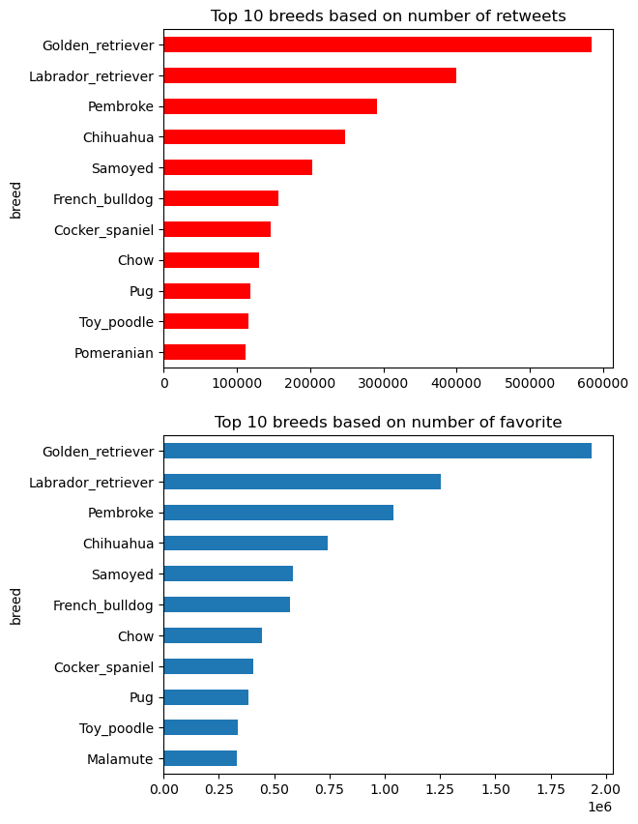

The above graphs illustrate the top 10 breeds, ranked by the number of retweets and favorites.

Looking at the chart "Top 10 dog breeds based on number of retweets" we can see that the range of dog types in the top 10 is similar to "Top 10 popular dog breeds based on quantity of Posts". Includes Golden Retriever, Labrador Retriever, Pembroke, Chihuahua, Pug, Toy Poodle, Chow, Samoyed, Pomeranian and Malamute dog breeds. Regarding the "Top 10 breeds based on number of favorite" there are some variations. Specifically, the 5th breed is French_bulldog, the 6th breed is Chow, the 7th breed is Cocker_spaniel, and the 10th breed is Malamute. This resemblance between retweets and favorites can be attributed to the likelihood of people who retweet also favoriting the tweet. Overall, the consistent pattern observed across all three graphs confirms that Golden_retriever, Labrador_retriever, Pembroke, and Chihuahua dominate as the most popular dog breeds, with the Golden_retriever securing the top position as the most favored breed overall.

Overall, the consistent pattern observed across all three graphs confirms that Golden_retriever, Labrador_retriever, Pembroke, and Chihuahua dominate as the most popular dog breeds, with the Golden_retriever securing the top position as the most favored breed overall.

1. **Which dog stage is the most commonly seen?**

We can see that the rating for popular dogs are very similar to each other.

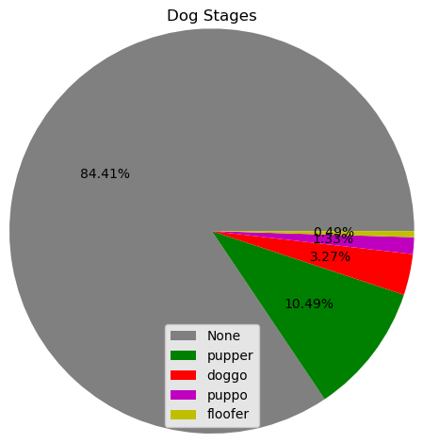

Dog stage chart

The chart shows that more than 84% of tweets have no dog-related information in the post. More than 10% mention the puppy dog. Other types of dogs are less commonly mentioned.

1. **What source do users use to post?**

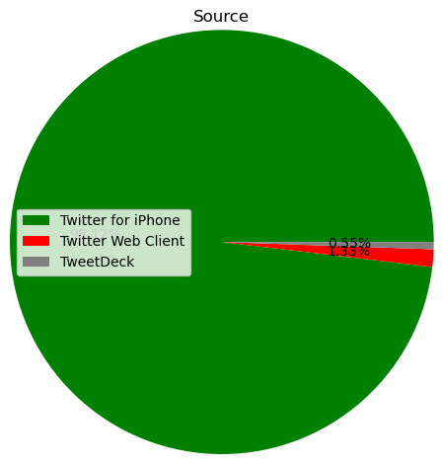

Source Chart

We can see that the majority of users are Iphone users(98%).

1. **What source do users use to post?**

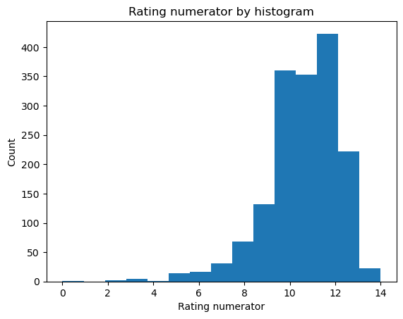

From the chart and data, we can notice that the most common rating in tweets is 12, which was mentioned in 421 tweets, followed by 10 (359 tweets), 11 (353 tweets), and 13 ( 222 tweets). The average rating calculated from these data points amounts to 10.85.